***Project: Comprehensive Digital Marketing for HAVMOR:***

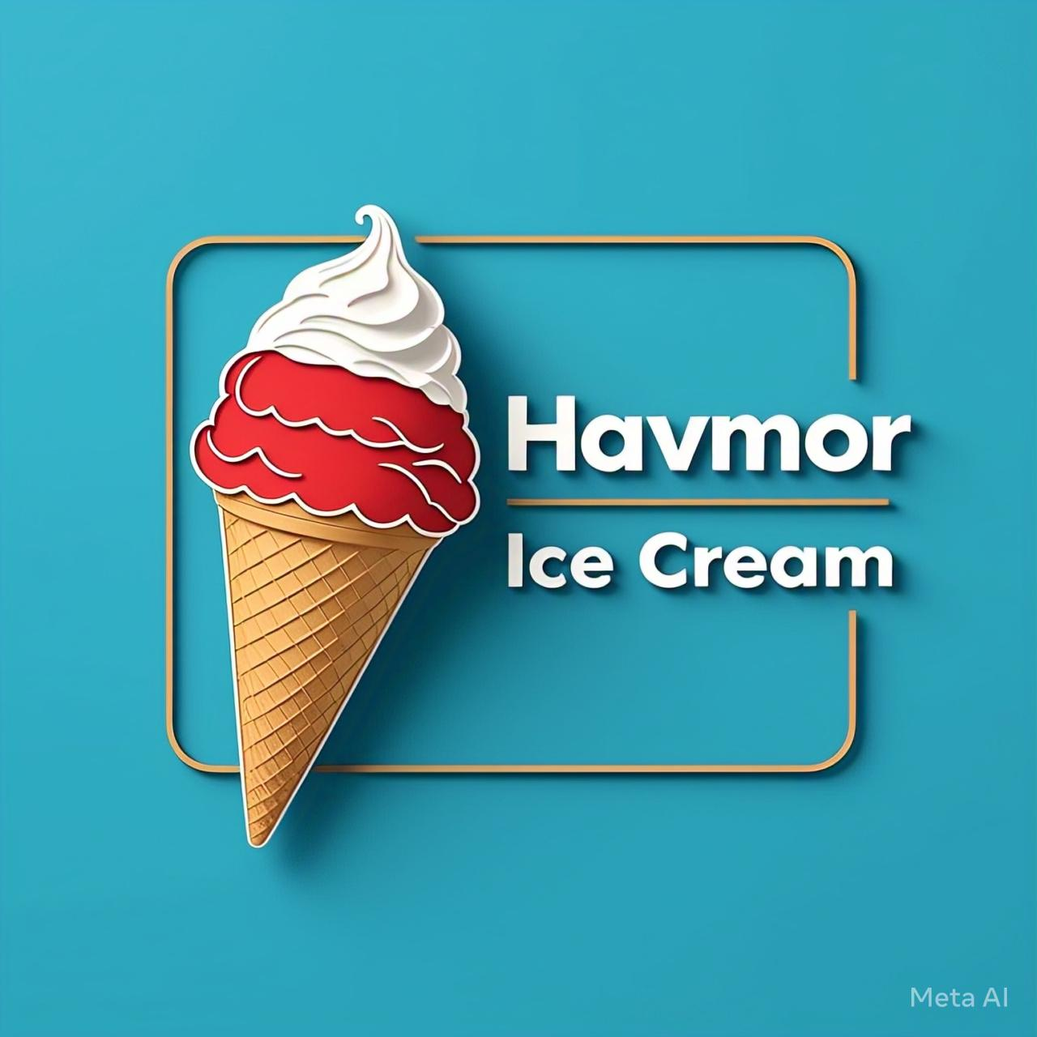

***1.Havmor’s Brand study:***

*Havmor is a renowned Indian ice cream brand that has been a part of the country's dessert landscape for over 75 years. With a wide range of unique and delicious flavors, Havmor has established itself as a leader in the Indian ice cream market.*

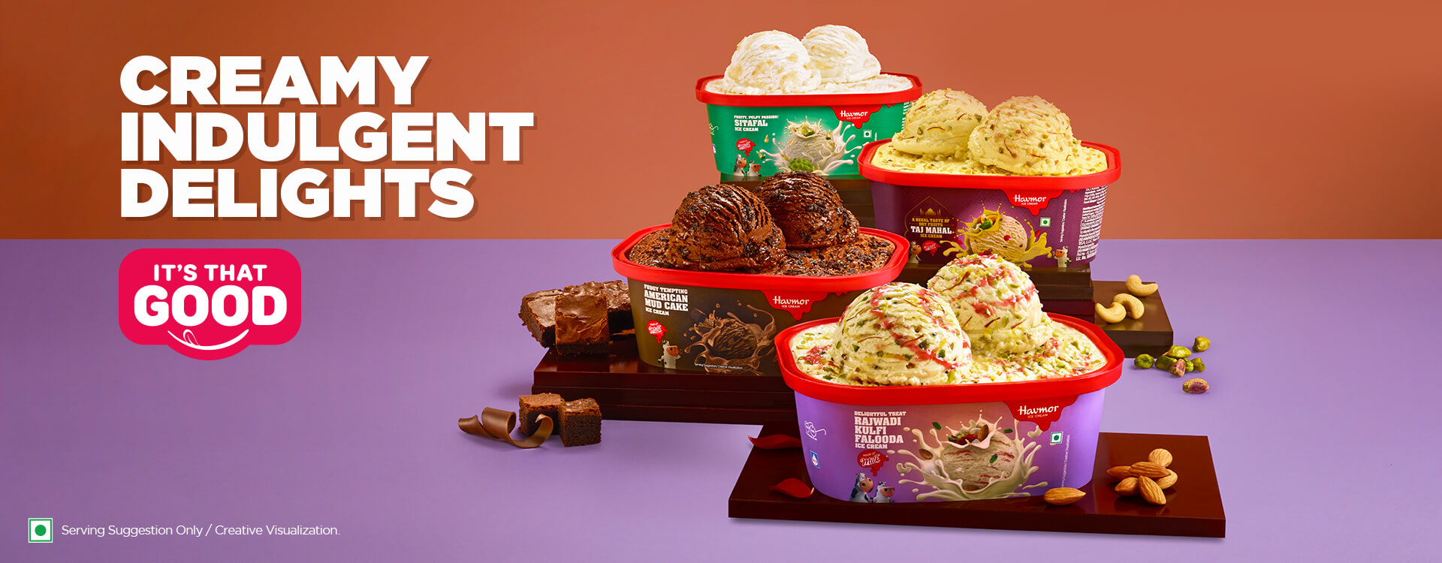

***Brand History***

*Havmor was founded in 1944 by Satish Chandra Choudhary in Ahmedabad, Gujarat. Initially, the brand started as a small ice cream parlor, but it quickly gained popularity due to its unique and delicious flavors. Over the years, Havmor has expanded its operations across India, and today it is one of the leading ice cream brands in the country.*

*1. Research Havmor Ice Cream's history, mission, values, and unique selling points.*

*2. Analyze the brand's current digital presence (website, social media, etc.).*

*3. Identify the target audience and their preferences.*

***2. Competitor Analysis:***

*Here are some of the main competitors of Havmor in the Indian ice cream market:*

***Local Competitors***

***1. Amul:*** *Amul is a well-known Indian dairy brand that offers a wide range of ice cream flavors*

***2. Vadilal:*** *Vadilal is another popular Indian ice cream brand that offers a variety of flavors and products.*

***3. Kwality Walls:*** *Kwality Walls is a popular Indian ice cream brand that offers a range of flavors and products.*

***4. Creambell:*** *Creambell is an Indian ice cream brand that offers a range of flavors and products.*

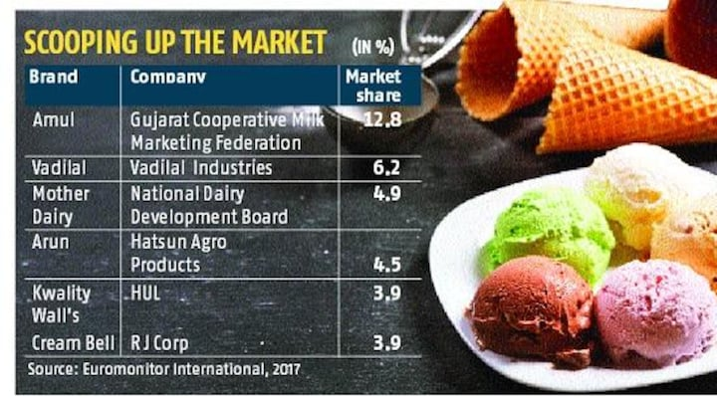

***International Competitors***

***1. Unilever (Wall's):*** *Unilever's Wall's brand is a global ice cream brand that offers a range of flavors and products in India.*

***2. Baskin-Robbins:*** *Baskin-Robbins is a global ice cream brand that offers a wide range of flavors and products in India.*

***3. Haagen-Dazs:*** *Haagen-Dazs is a global premium ice cream brand that offers a range of unique and delicious flavors in India.*

***4. Ben & Jerry's:*** *Ben & Jerry's is a global ice cream brand that offers a range of unique and delicious flavors in India.*

*These are some of the main competitors of Havmor in the Indian ice cream market. The brand competes with these players on factors like product quality, pricing, distribution, and marketing.*

***3.Buyer's Audiences persona:***

***1. Demographics:*** *Ice cream lovers, families, young adults, and children.*

***2. Interests:*** *Foodies, dessert enthusiasts, and those seeking indulgent treats.*

***3. Pain points:*** *Craving something delicious, seeking comfort food, or looking for a special treat.*

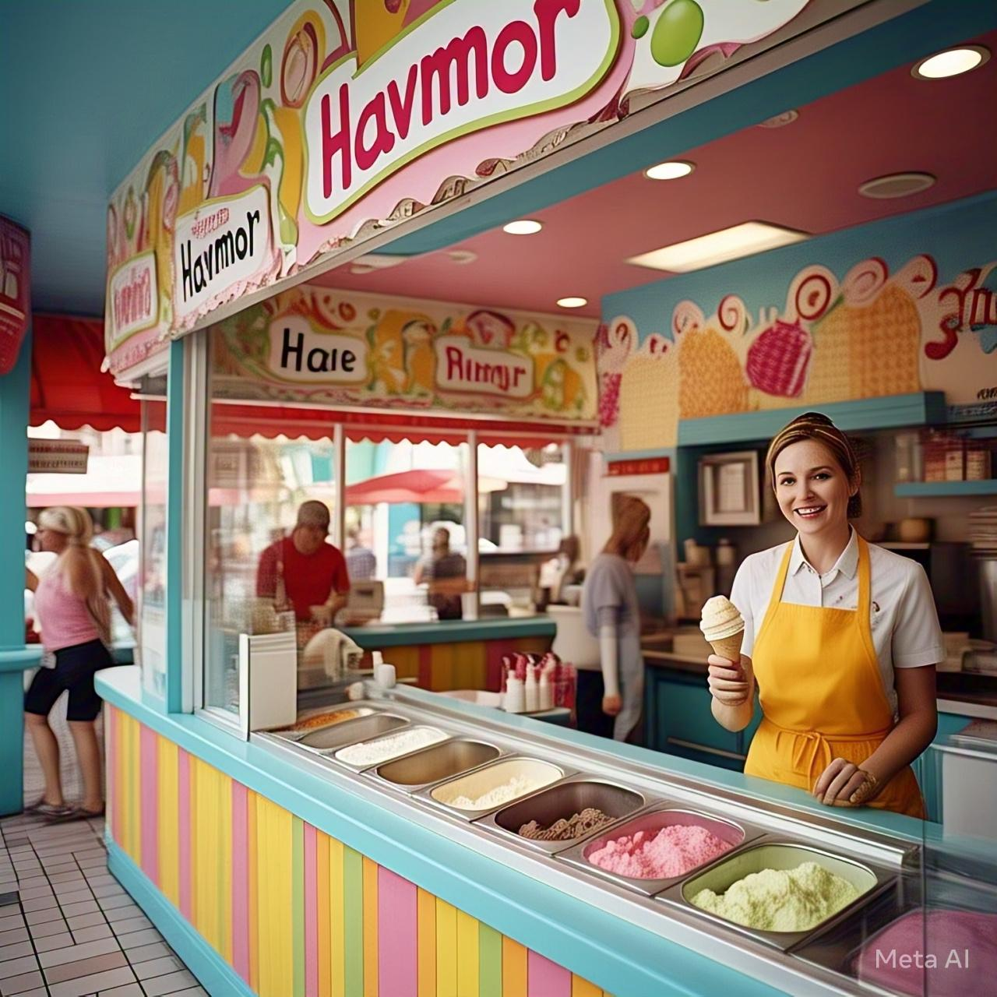

***SEO and key word research:***

*Here's an overview of SEO and keyword research for Havmor:*

***SEO Objectives***

*1. Increase website traffic and online visibility*

*2. Improve brand credibility and reputation*

*3. Drive sales and conversions through online channels*

***Keyword Research***

***1. *Primary Keywords*:*** *ice cream, Indian ice cream, Havmor ice cream*

***2. *Secondary Keywords*:*** *dessert, sweet treats, frozen yogurt, ice cream flavors*

***3. *Long-Tail Keywords*:*** *best ice cream in India, unique ice cream flavors, Havmor ice cream near me*

***4. *Keyword Phrases*:*** *buy ice cream online, ice cream delivery, ice cream shops near me*

***On-Page Optimization***

***1. *Title Tags*:*** *Include primary keywords in title tags, e.g., "Havmor Ice Cream - Best Ice Cream in India"*

***2. *Meta Descriptions*:*** *Write compelling and keyword-rich meta descriptions, e.g., "Indulge in the creamiest and most delicious ice cream in India with Havmor. Try our unique flavors today!"*

***3. *Header Tags*:*** *Use header tags (H1, H2, H3) to structure content and highlight keywords*

***4. *Content Optimization*:*** *Use primary and secondary keywords naturally throughout the content*

***5. *Image Optimization*:*** *Use descriptive alt tags and file names that include target keywords*

*1. Conduct keyword research for Havmor Ice Cream.*

*2. Analyze search volume, competition, and relevance.*

*3. Optimize the website and content for targeted keywords.*

***3. Content ideas and Marketing strategies:***

***Content Mission Statement***

*"Delight, engage, and inspire our audience with mouth-watering content that showcases Havmor's rich legacy, quality products, and joyful experiences."*

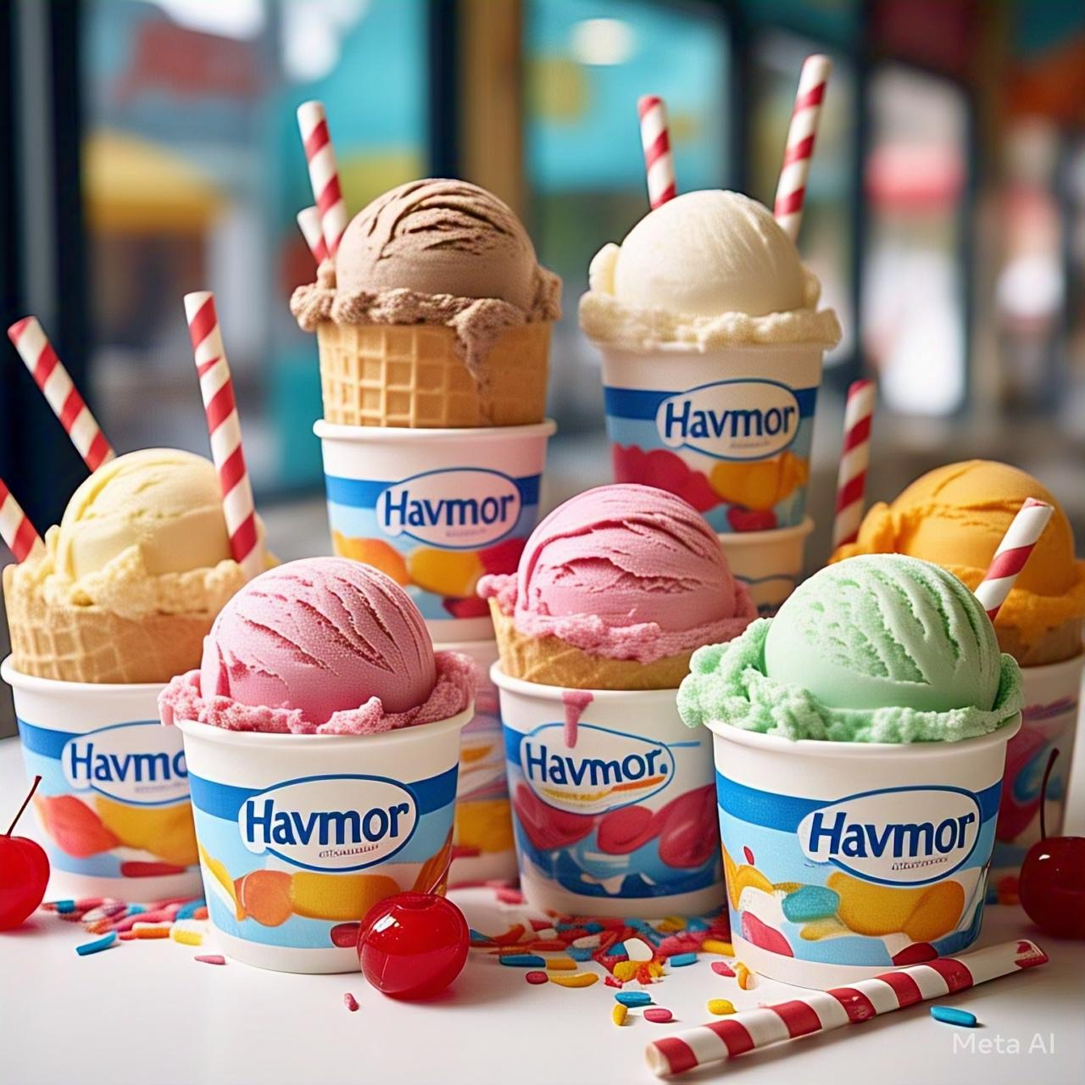

***Content Pillars***

***1. *Product Showcase*:*** Highlight Havmor's wide range of ice cream flavors, sundaes, and other desserts.

***2. *Havmor Stories*:*** Share the brand's legacy, history, and values to create an emotional connection.

***3. *Joyful Moments*:*** Capture the happiness and excitement of enjoying Havmor ice cream with family and friends.

***4. *Seasonal & Timely Content*:*** Create content around festivals, holidays, and seasonal flavors.

***5. *User-Generated Content*:*** Encourage customers to share their Havmor experiences and feature them on social media.

***Marketing strategies:***

*Here are some marketing strategies that Havmor could consider:*

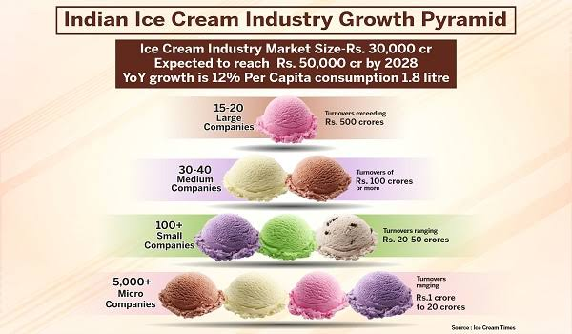

***Digital Marketing***

***1. *Social Media Marketing*:*** *Leverage platforms like Facebook, Instagram, Twitter, and Pinterest to engage with customers, share product information, and run targeted ads.*

***2. *Influencer Marketing*:*** *Partner with social media influencers and bloggers in the food and dessert space to promote Havmor's products.*

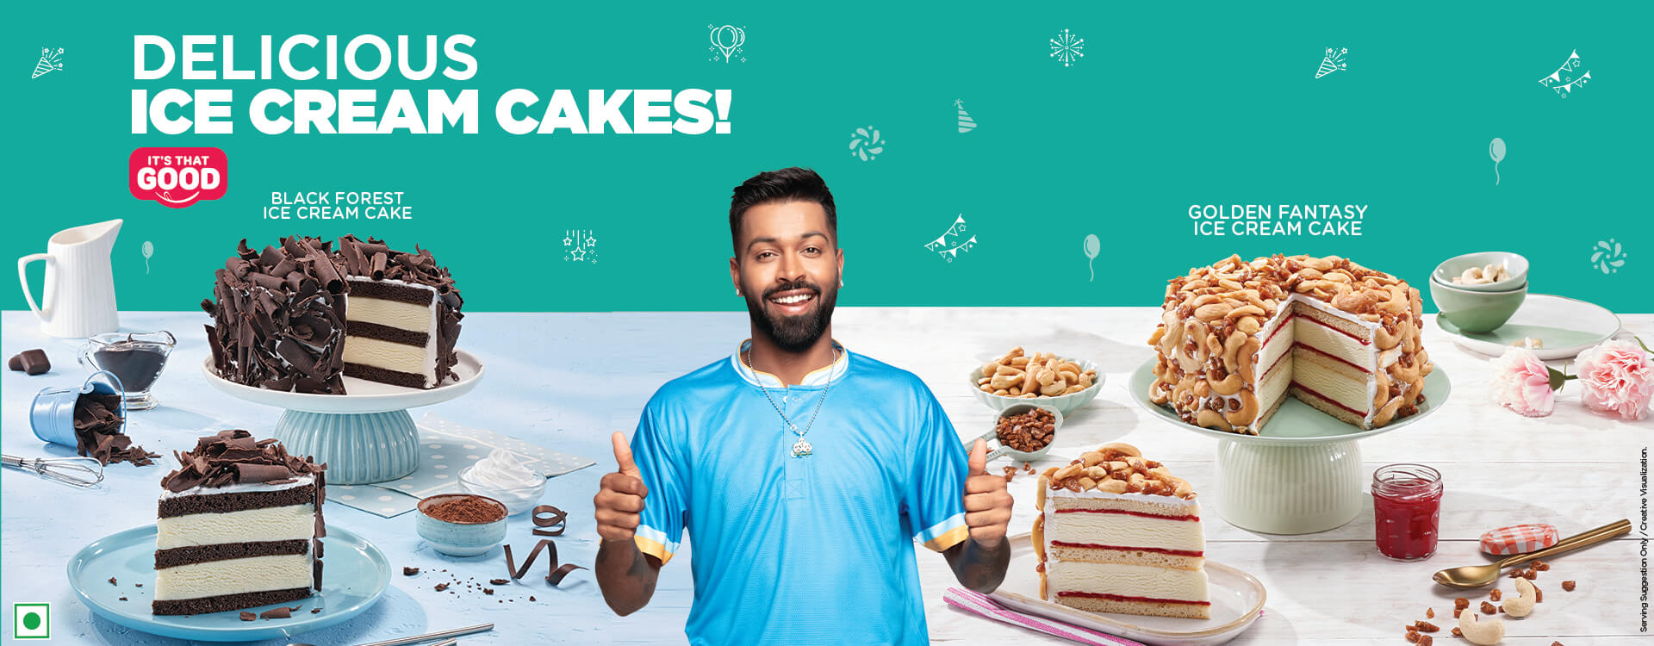

***3. *Email Marketing*:*** *Build an email list and send regular newsletters to subscribers showcasing new products, promotions, and events.*

***4. *Content Marketing*:*** *Create engaging content like blog posts, videos, and infographics that provide value to customers and promote Havmor's products.*

***Offline Marketing***

***1. *Experiential Marketing*:*** *Create immersive experiences for customers through events, activations, and pop-ups that showcase Havmor's products.*

***2. *Partnerships and Collaborations*:*** *Partner with restaurants, cafes, and food delivery services to offer Havmor's products to a wider audience.*

***3. *Trade Shows and Events*:*** *Participate in trade shows and events to showcase Havmor's products and connect with customers and partners.*

***4. *Loyalty Program*:*** *Implement a loyalty program that rewards customers for repeat purchases and encourages retention.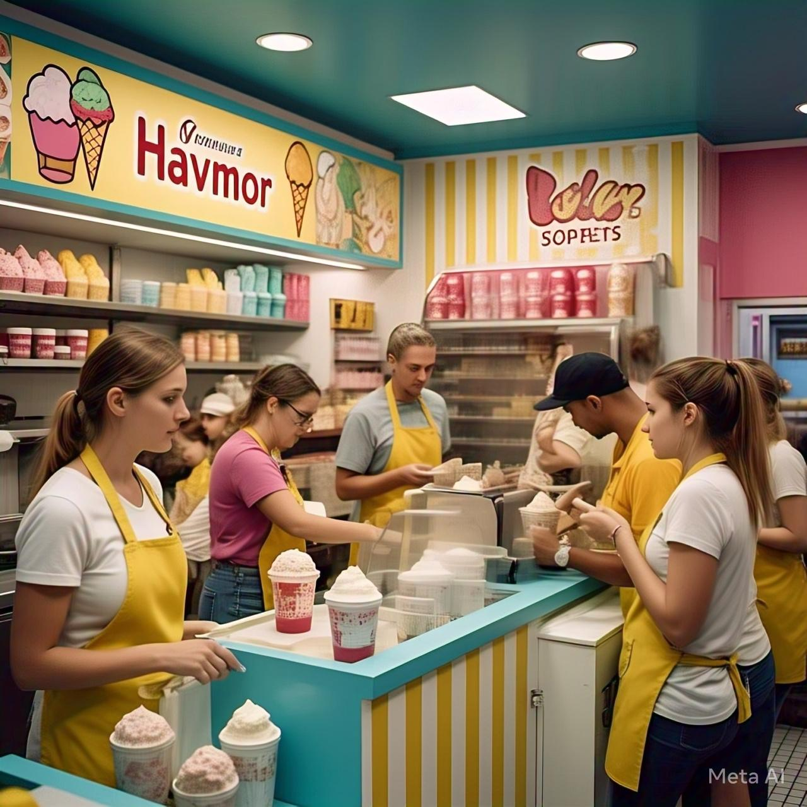*

***4. Content creation and curation:***

***Post creation:***

*1. Develop a content calendar for Havmor Ice Cream.*

*2. Create content ideas (blog posts, social media posts, videos, etc.).*

*3. Define the tone, style, and format for each content type.*

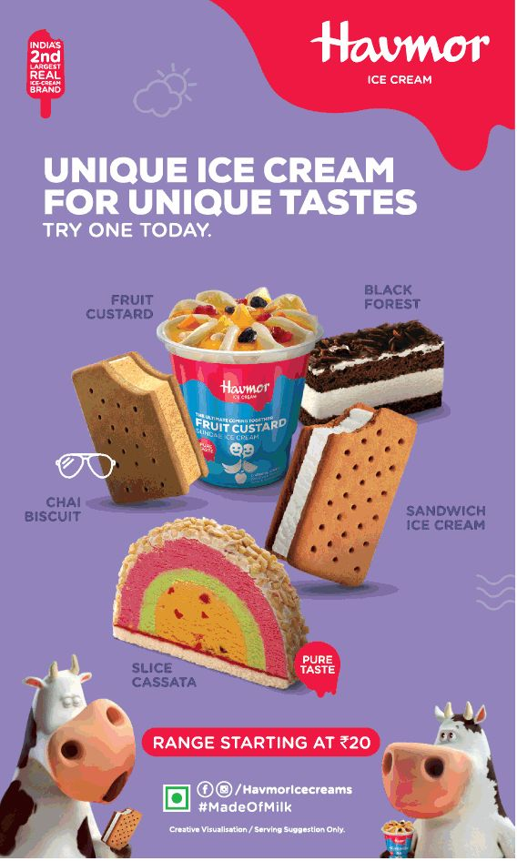

***Content Calendar***

*1. Monthly themes (e.g., summer flavors, holiday treats)*

*2. Weekly social media posts (3-4 posts per week)*

*3. Bi-monthly blog posts (2-3 posts per month)*

*4. Quarterly video content (1-2 videos per quarter)*

*5. Seasonal and timely content (e.g., Diwali, Christmas)*

***Content Types***

***1. *Social Media Posts*:*** *Engaging visuals, videos, and captions for Instagram, Facebook, Twitter, and Pinterest.*

***2. *Blog Posts*:*** *In-depth articles about Havmor's history, product launches, and behind-the-scenes stories.*

***3. *Videos*:*** *Product showcases, brand stories, and joyful moments captured on film*

***4. *Influencer Partnerships*:*** *Collaborate with social media influencers and bloggers in the food and dessert space.*

***5. *Email Newsletters*:*** *Exclusive offers, new flavor announcements, and brand updates for subscribers.*

***Design/video editing:***

*1. Create high-quality, engaging content (blog posts, social media posts, videos, etc.).*

*2. Curate user-generated content (customer photos, reviews, etc.).*

*3. Repurpose content for different channels (e.g., turning a blog post into a video).*

***Social media and email Ad compaings:***

*Here are some social media and email ad campaign ideas for Havmor:*

***Social Media Campaigns***

***1. *"Summer of Fun" Campaign*:*** *Create a series of fun and engaging ads showcasing Havmor's ice cream flavors and promoting summer-themed contests and giveaways.*

***2. *"Flavor of the Month" Campaign*:*** *Highlight a new and unique flavor every month, using eye-catching visuals and mouth-watering descriptions to drive sales and engagement.*

***3. *"Share Your Havmor Moment" Campaign*:*** *Encourage customers to share photos or videos of themselves enjoying Havmor ice cream, using a branded hashtag and tagging friends to increase engagement and user-generated content.*

***4. *"Havmor Loves India" Campaign*:*** *Celebrate India's diversity and richness by showcasing Havmor's unique and traditional flavors, using vibrant visuals and storytelling to connect with customers.*

***Email Campaigns***

***1. *"Welcome to Havmor" Campaign*:*** *Send a warm welcome email to new subscribers, offering a discount code or a free sample to encourage first-time purchases.*

***2. *"Flavor of the Month" Newsletter*:*** *Send a monthly newsletter showcasing the new flavor of the month, along with special promotions, discounts, and events.*

***3. *"Exclusive Offers" Campaign*:*** *Send targeted emails to loyal customers and subscribers, offering exclusive discounts, freebies, and early access to new products.*

***4. *"Havmor's Birthday Club" Campaign*:*** *Send a special birthday email to subscribers, offering a free ice cream or a discount code to celebrate their special day.*

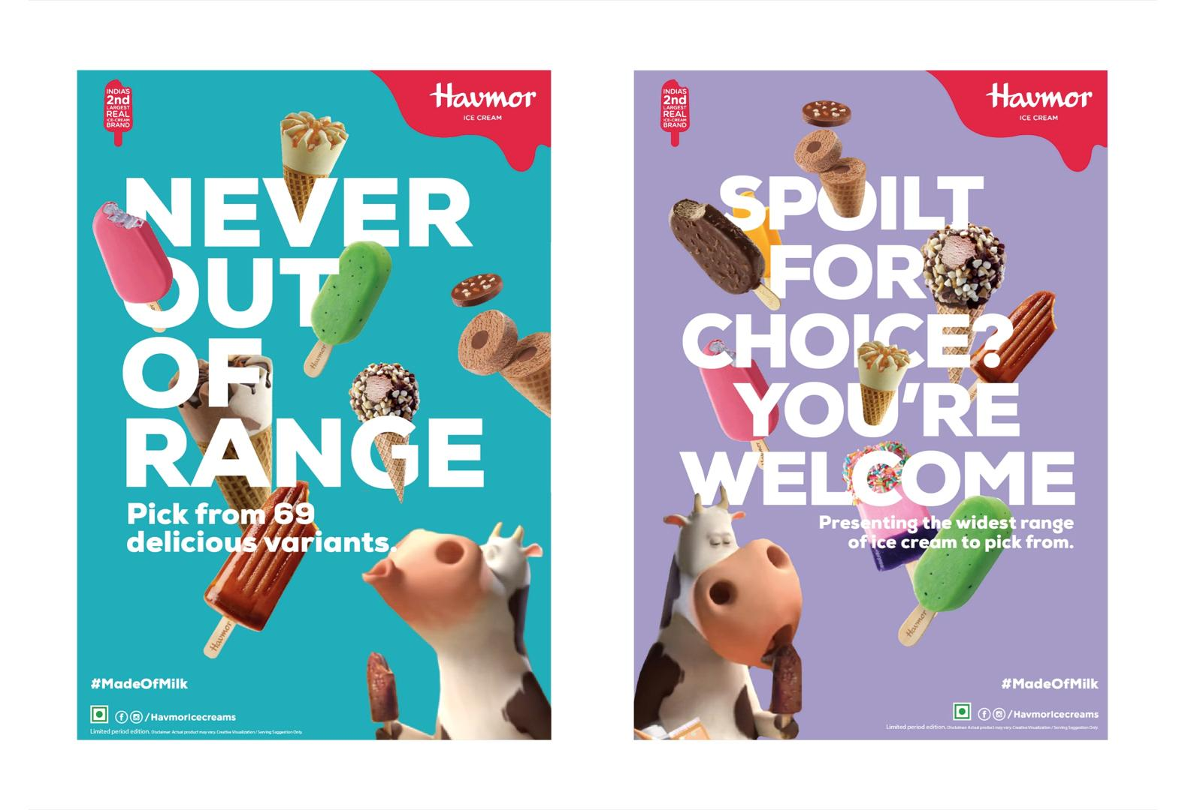

***Ad Creative***

***1. *Image Ads*:*** *Use high-quality images of Havmor's ice cream flavors, with mouth-watering descriptions and clear calls-to-action.*

***2. *Video Ads*:*** *Create engaging and fun videos showcasing Havmor's products, using storytelling and humor to connect with customers.*

***3. *Carousel Ads*:*** *Use carousel ads to showcase multiple flavors and products, with each card highlighting a unique feature or benefit.*

***4. *Story Ads*:*** *Use Instagram and Facebook stories to share behind-the-scenes content, sneak peeks, and exclusive offers to engage with customers.*

***Budget Allocation***

***1. *Facebook and Instagram*:*** *Allocate 60% of the budget to Facebook and Instagram ads, targeting customers based on demographics, interests, and behaviors.*

***2. *Email Marketing*:*** *Allocate 20% of the budget to email marketing campaigns, targeting subscribers and loyal customers with exclusive offers and promotions.*

***3. *Twitter and LinkedIn*:*** *Allocate 10% of the budget to Twitter and LinkedIn ads, targeting customers based on interests, keywords, and demographics.*

***4. *Influencer Marketing*:*** *Allocate 10% of the budget to influencer marketing campaigns, partnering with social media influencers and content creators to promote Havmor's products*

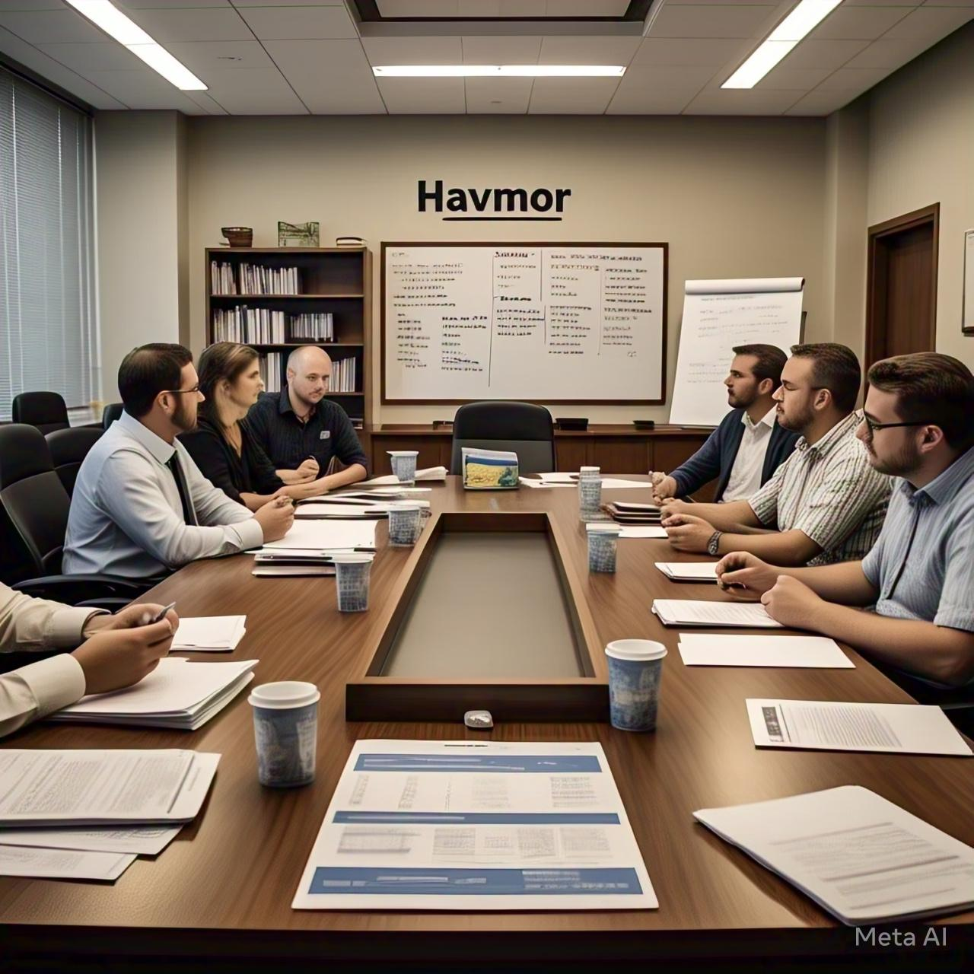

***Metrics for Success***

*1. Engagement rates (likes, comments, shares)*

*2. Follower growth rate*

*3. Website traffic and blog post views*

*4. Email open and click-through rates*

*5. Sales and revenue growth*

*This content strategy will help Havmor build a strong online presence, engage with customers, and drive sales.*

***Conclusion:***

*The Havmor content strategy aims to create a delightful and engaging online experience that showcases the brand's rich legacy, quality products, and joyful moments. By leveraging a mix of product showcases, brand stories, user-generated content, and seasonal timely content, Havmor can:*

*1. Increase brand awareness and affinity*

*2. Drive website traffic and sales*

*3. Engage with customers and build a loyal community*

*4. Differentiate itself from competitors in the ice cream market*

*This project will give you a comprehensive understanding of Havmor Ice Cream's digital marketing landscape and provide actionable recommendations for improvement.*

***Recommendations:***

*1. Develop a content calendar to ensure consistent posting and engagement*

*2. Invest in high-quality visuals and video content to showcase products and brand stories*

*3. Collaborate with influencers and bloggers to expand reach and credibility*

*4. Monitor and measure performance using metrics such as engagement rates, follower growth, and sales*

***Future Outlook:***

*By implementing this content strategy, can strengthen its online presence, drive business growth, and become a leader in the ice cream market.*



***Name: DEGALA RUBIYA SULTHANA***

***Email I'd: rubiyasultana273@gmail.com***

***Hall ticket number: 22360014003***

***College: Vasavi Mahila Kalasala***

***University: Rayalaseema University***